**SSIS HW 01**

Maitri Brahmbhatt

1. **Export the HumanResources.Employee table from AdventureWorks**
2. We can export data in both the ways i) using wizard and ii) creating a SSIS package from scratch. I have done in both the ways. Here I am going to explain how I did it by creating a SSIS package. So first I dragged **Data Flow Task** from SSIS Toolbox

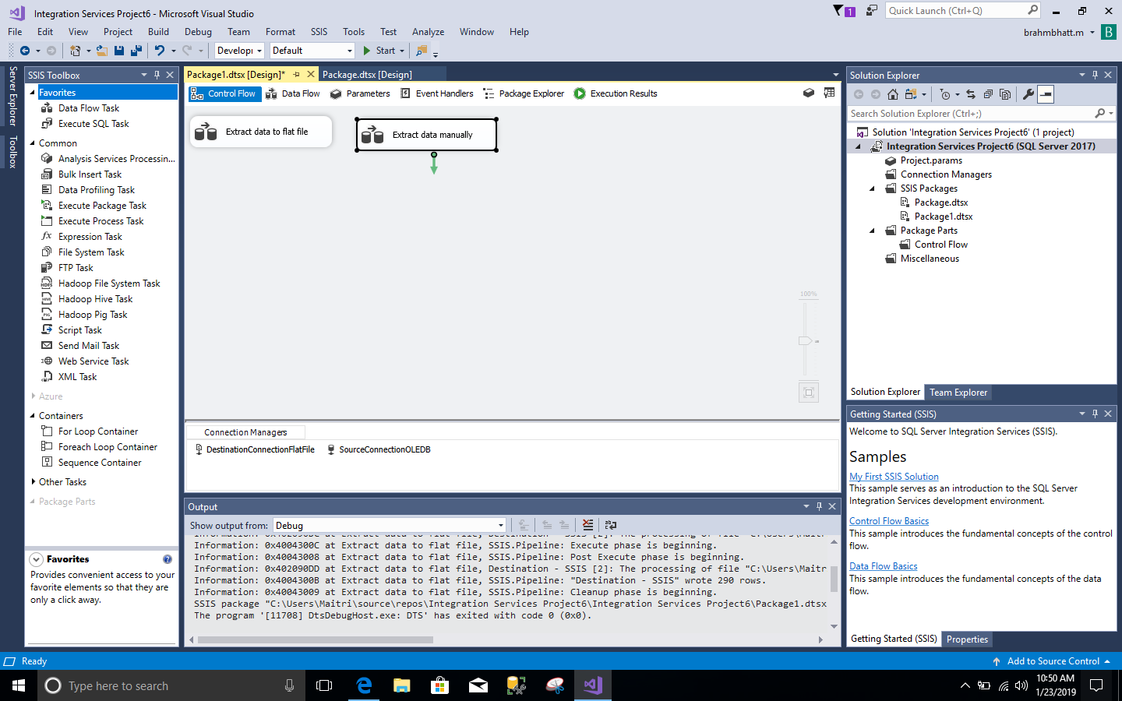

1. Then I went into the Data Flow and dragged **Source Assistant** from toolbox. It will immediately open a window, in which I selected source type **SQL Server** and selected **New** connection. As soon as you hit new, it will open another window where I gave my server name and selected **AdventurWorks2014** database and hit ok.

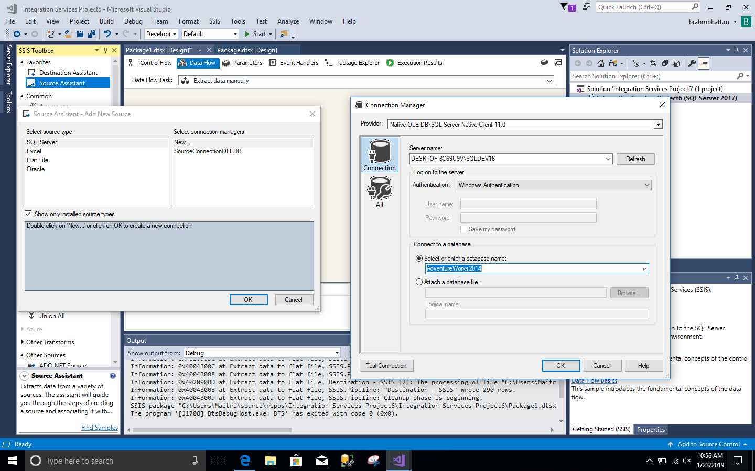

1. Then I edited **OLB DB Source – Employee** and added **[HumanResources].[Employee]** table. By clicking on preview, we can also take a look on how table looks.

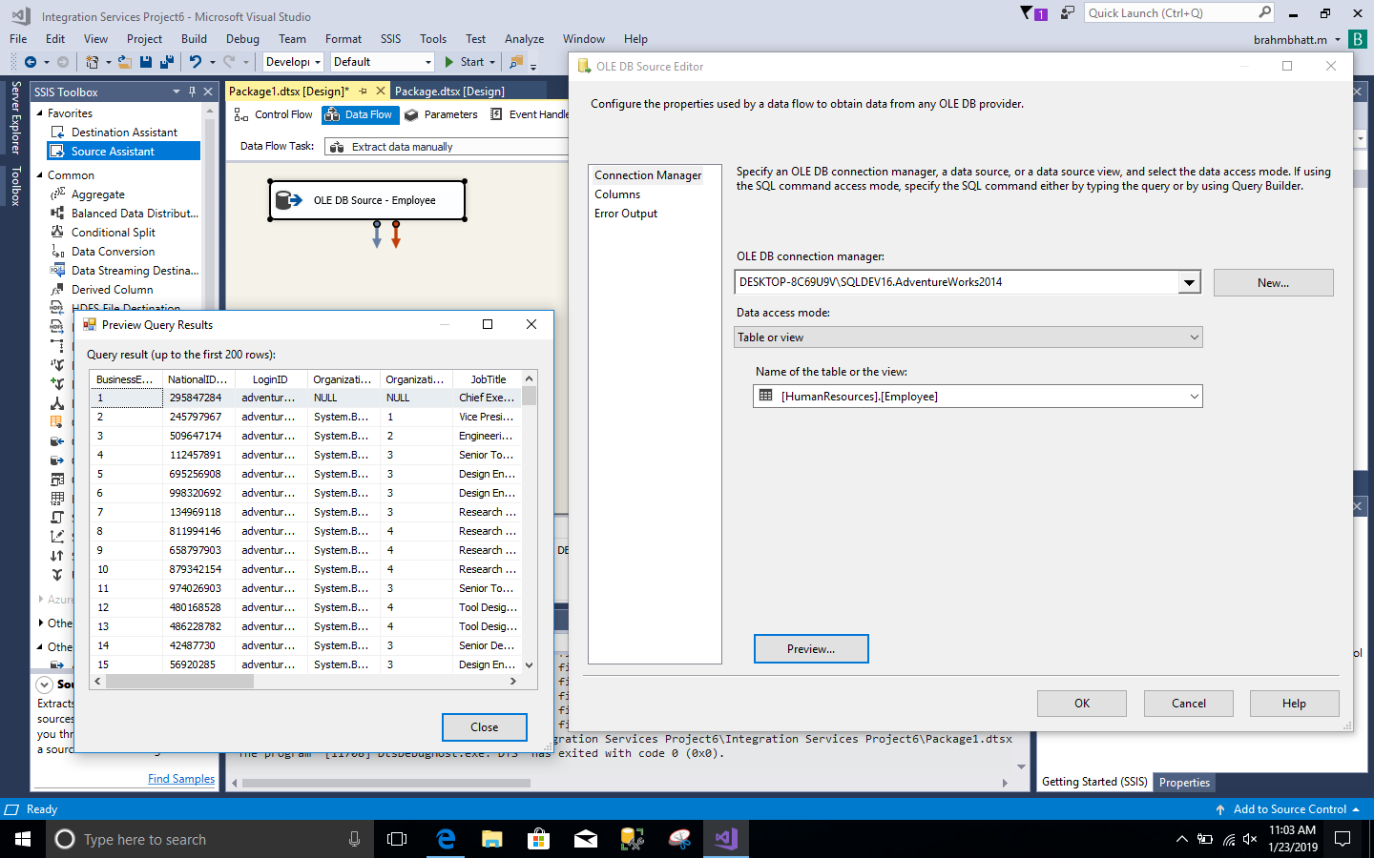

1. Then I dragged **Flat File Destination** from ‘Other Destinations’ menu and I joined it to OLE DB Source – Employee. After that I edited Flat File, one window opened and I selected new connection manager. Then another window opened and I gave the file name as **SSIS2**

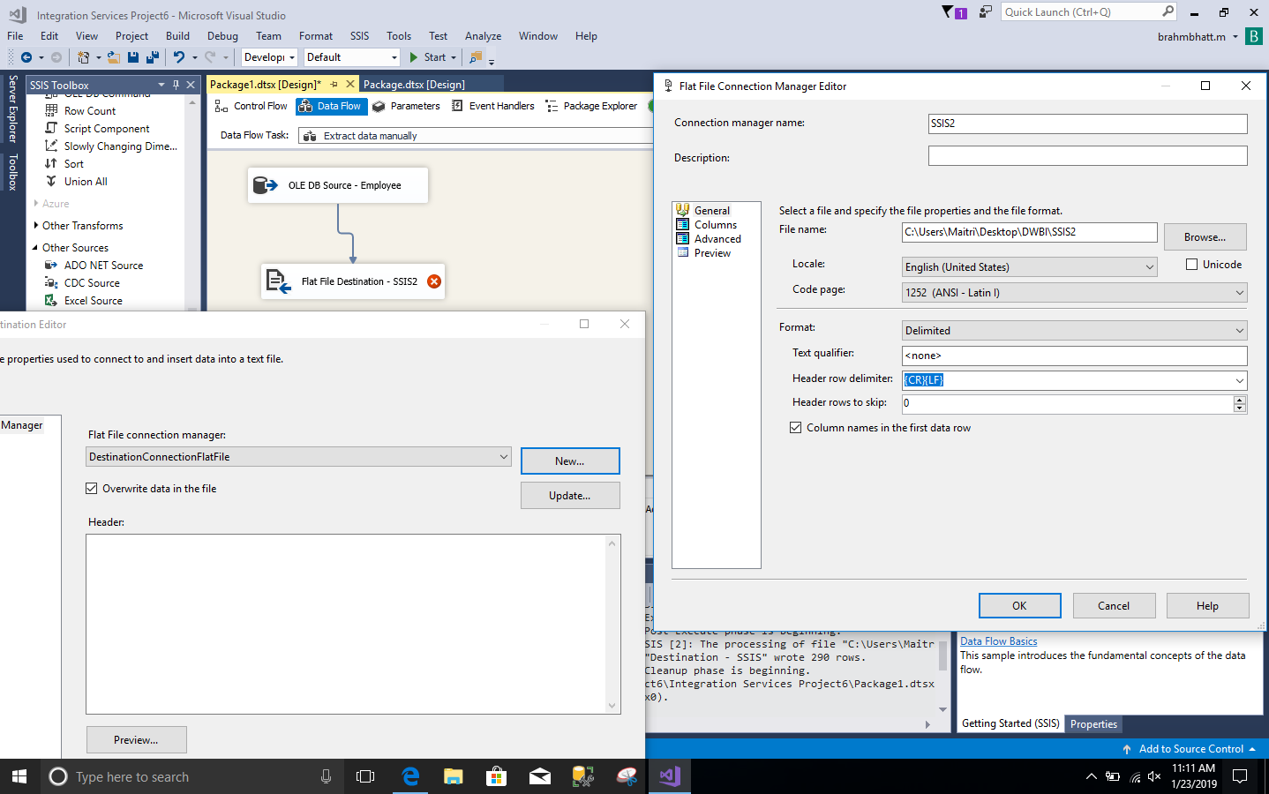

1. Then I again clicked on flat file destination – SSIS2 and selected mapping to check if its properly done. Then I hit OK.

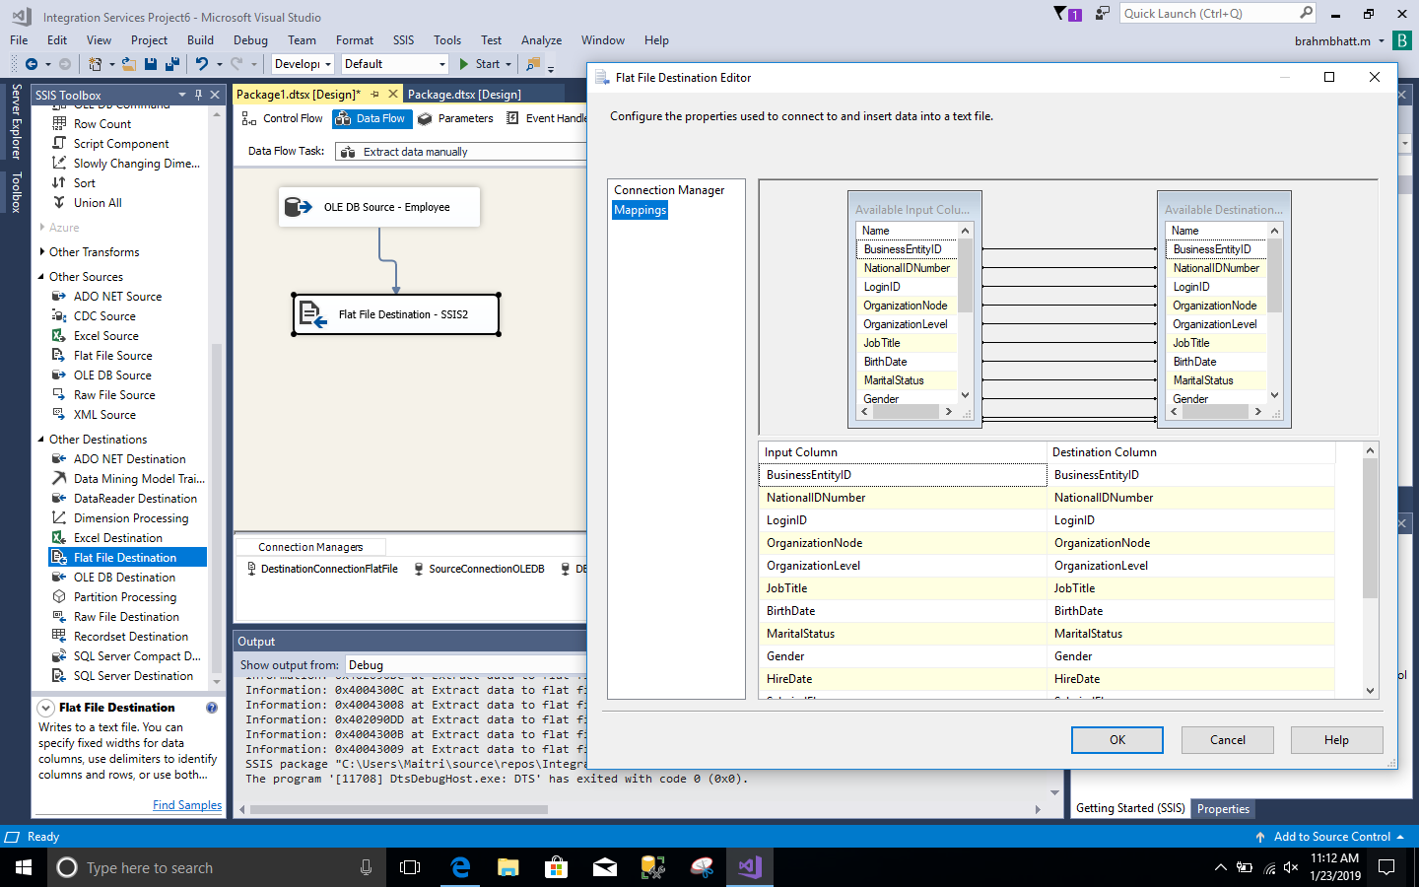

1. Once everything is done, then hit the start button. It will start exporting data to csv format. Ones the process it done and successful then it will give green checkmarks as shown in picture.

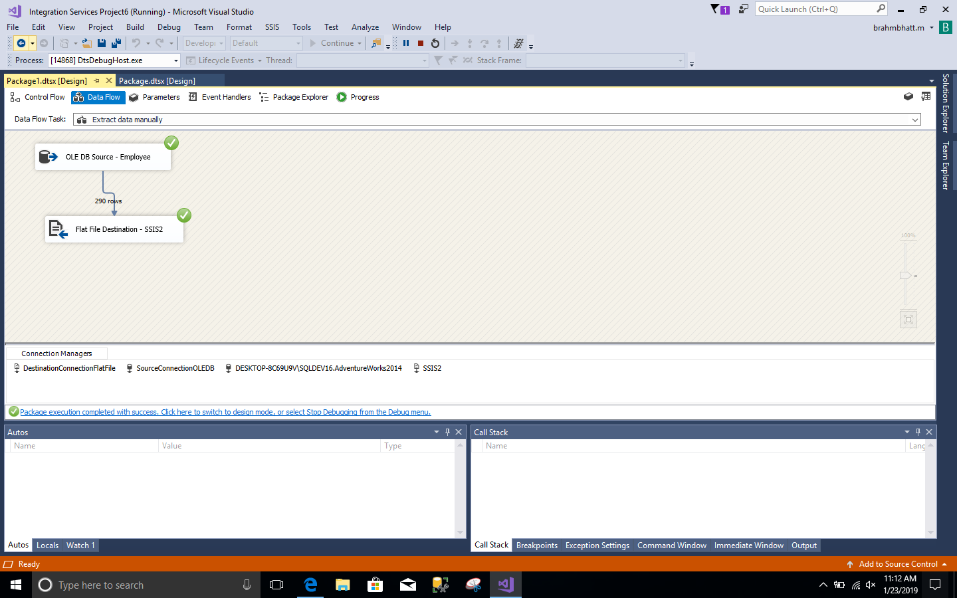

1. As a result, you can see SSIS2 file in csv format at your destination.

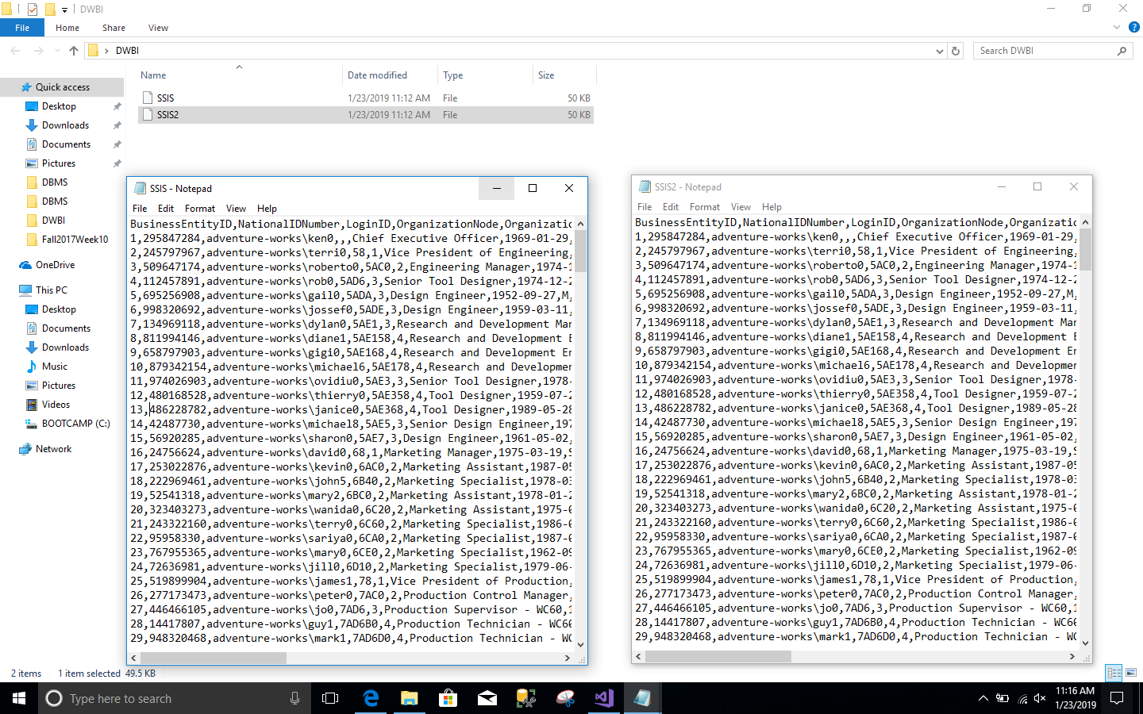

1. **Create a script for staging table for importing the employee data**

As a staging table, I created **[dbo].[Information_emp]** table in my own **Maitri** database. Here is the code:

USE [Maitri]

GO

SET ANSI_NULLS ON

GO

SET QUOTED_IDENTIFIER ON

GO

CREATE TABLE [dbo].[Information_emp](

[BusinessEntityID] [int] NOT NULL,

[NationalIDNumber] [nvarchar](15) NOT NULL,

[LoginID] [nvarchar](256) NOT NULL,

[Organiza[dbo].[Information_emptionNode] [hierarchyid] NULL,

[OrganizationLevel] AS ([OrganizationNode].[GetLevel]()),

[JobTitle] [nvarchar](50) NOT NULL,

[BirthDate] [date] NOT NULL,

[MaritalStatus] [nchar](1) NOT NULL,

[Gender] [nchar](1) NOT NULL,

[HireDate] [date] NOT NULL,

[SalariedFlag] [int] NOT NULL,

[VacationHours] [smallint] NOT NULL,

[SickLeaveHours] [smallint] NOT NULL,

[CurrentFlag] [int] NOT NULL,

[rowguid] [uniqueidentifier] ROWGUIDCOL NOT NULL,

[ModifiedDate] [datetime] NOT NULL

) ON [PRIMARY]

GO

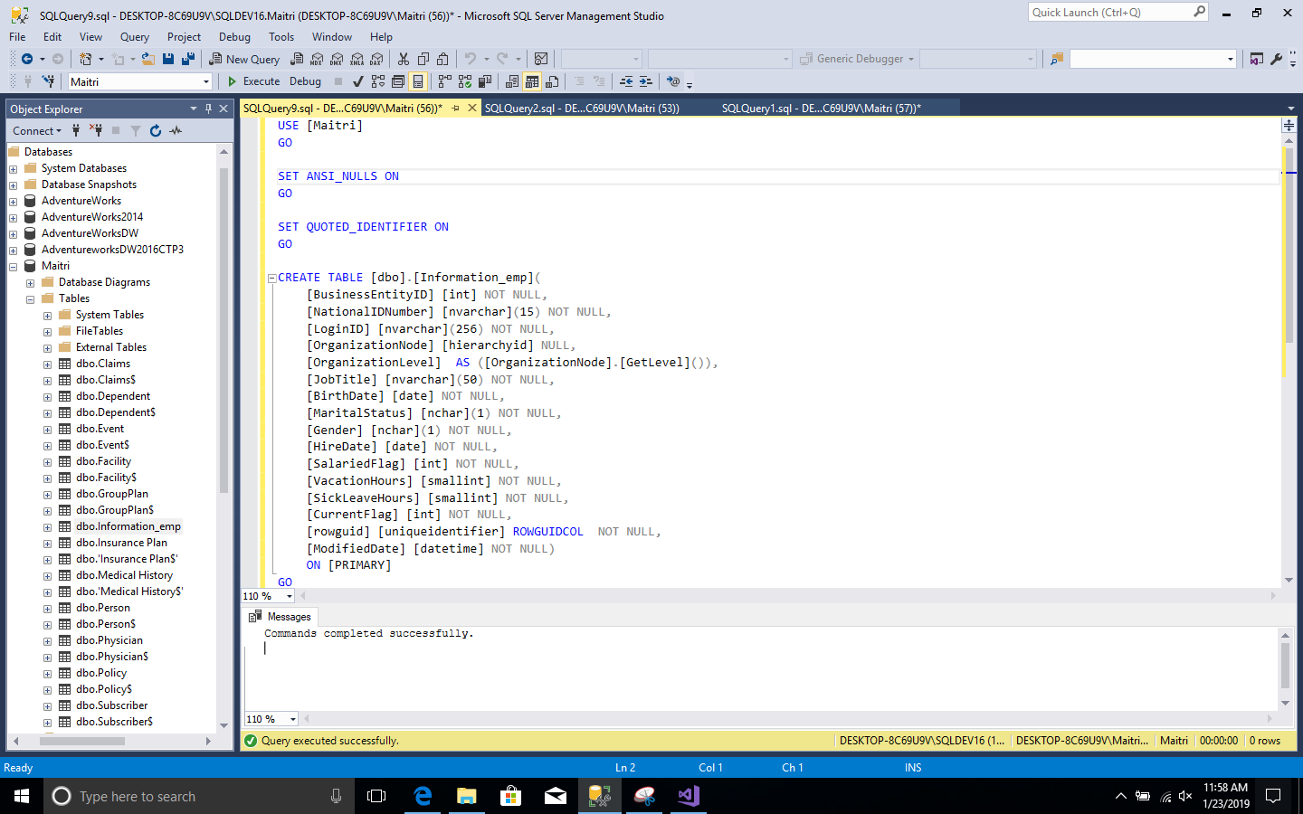

1. **Create a SSIS package to load the data**
2. Now to load data from file **SSIS2** to table **[dbo].[Information_emp]**, again I created data flow then dragged Source Assistant and selected SSIS2 as a connection manager. Then hit OK.

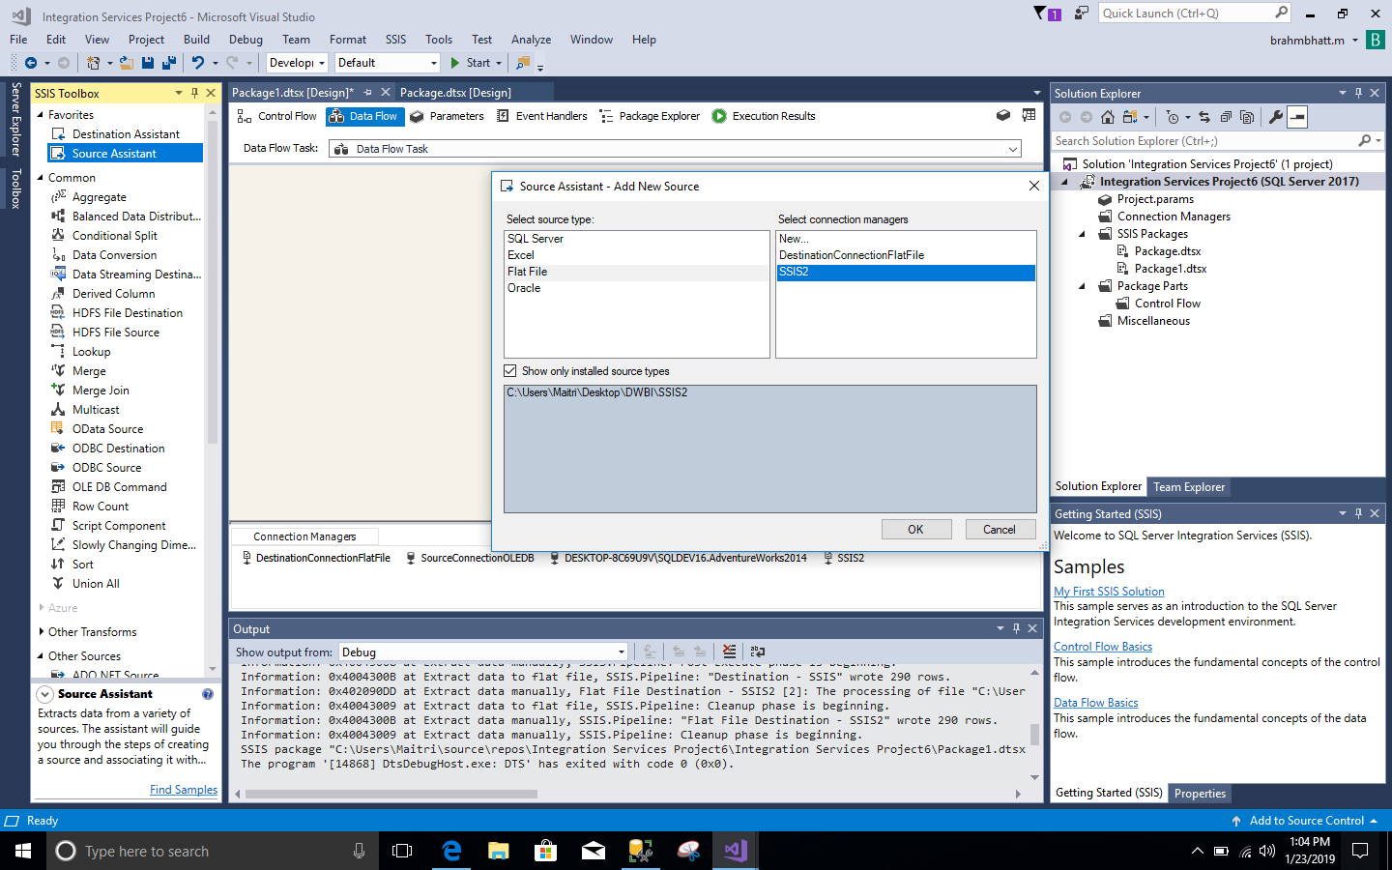

1. Then I dragged Destination Assistant and selected **New** as a connection manager. After that one wiondow poped up, in that I gave my server name and selected database as **Maitri** and table as **[dbo].[Information_emp]**.

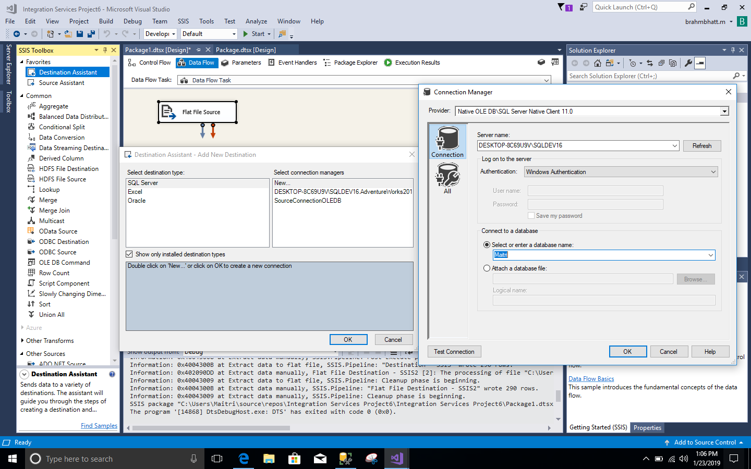

1. After connecting Flat file Source to OLD DB Destination – Employee, I checked if mapping if proper by clicking on OLD DB Destination – Employee.

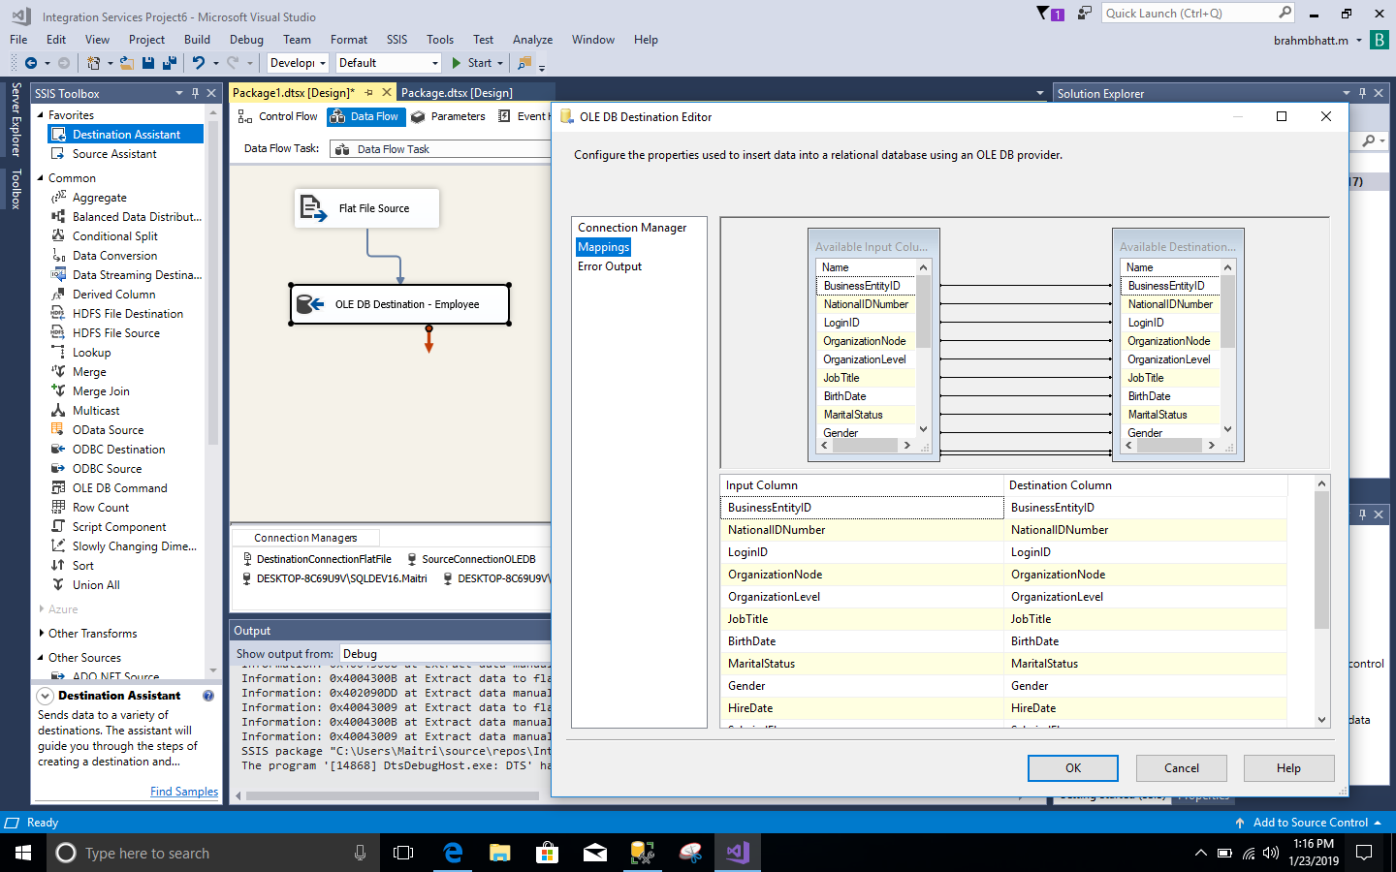

1. At last I hit **Start** button to load data into the table. And the data was loaded successfully as it gave me green checkmarks.

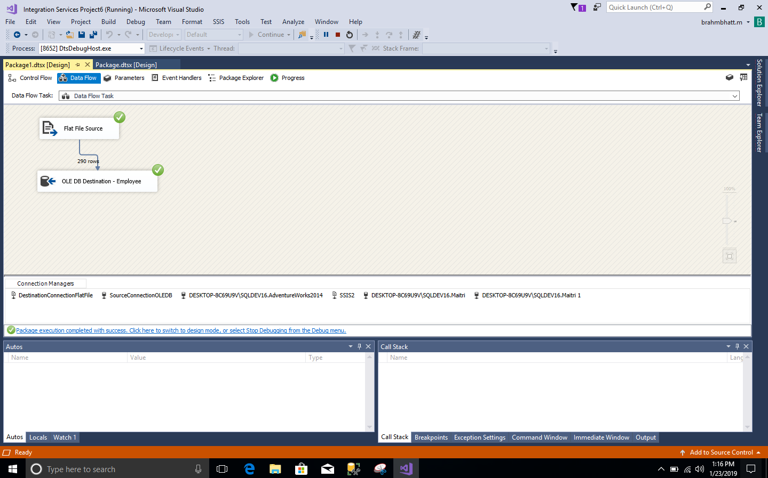

1. As a result, we can see data from **SSIS2** file had been loaded successfully into **[dbo].[Information_emp]** table.

